**Batch:B2-2/H2_1 Roll No:-16010122151**

**Experiment 06**

|  |
| --- |
| **Title: Working with Geospatial data** |

# Objective:

# *Search/locate and download the geospatial Data (Use same dataset if it contains location information)*

# *To learn how to visualize geospatial data*

# *Auto Geo-tagging*

# *Custom Geo-tagging*

# *Apply heat map*

# *Try various forms of heat maps*

# *Analyze the visualization and write your interpretation after observation on heat-map*

# [*Interactive*](https://www.youtube.com/watch?v=_h_WjKhApFc&ab_channel=HarpreetBedi) *filtering over map*

# *Following maps should be demonstrated*

# *Proportional symbol maps*

# *Choropleth maps (filled maps)*

# *Point distribution maps*

# *Density maps (heatmaps)*

# *Flow maps (path maps)*

# *Spider maps (origin-destination maps)*

# Course Outcome:

# CO1: Learn how to locate and download datasets, extract insights from that data and present their findings in a variety of different formats.

# CO3 Apply data visualization best practices

# Books/ Journals/ Websites referred:- 1) https://boralot.com/ -websites/

# Resources used:- 1)https://www.youtube.com/watch?v=6tklXV-Hh24.

# Theory:

# Definition:

(Theory related to experiment needed to perform - Students should write)

# Following points should be written by students

# Observation after plotting data

# Observation after plotting various forms of maps like based on visualization Que

# Interpretation of visualized map

# Note: Detail observation needed along screenshots wherever required 1) Proportional Symbol Maps 1)Data Interpretation:- Proportional symbol maps simplify data interpretation and make it accessible to a wide audience. They provide an intuitive way to grasp the gender-based sales data, which can be useful for decision-makers and stakeholders.

# 2)Regional Disparities:- The map might reveal regional disparities in gender-based sales. Some areas may have relatively balanced sales between genders, while others might show significant differences in sales. This information can be valuable for businesses looking to target specific regions or adjust their marketing strategies.

# 3)Comparative Analysis:- By comparing the size of symbols within each region, you can easily identify whether one gender has higher sales than the other. Larger symbols indicate higher sales for that gender in a specific location, while smaller symbols represent lower sales. 2) Choropleth Maps

# 

# 1)Comparison between Regions:- Choropleth maps facilitate easy comparisons between regions. You can quickly assess which regions perform better or worse in terms of sales. This information is valuable for businesses to allocate resources or tailor marketing strategies accordingly.

# 2)Geographic Insights:- The map helps in identifying correlations between sales and geographic factors. For example, you might notice that coastal areas have higher sales due to tourism, while mountainous regions have lower sales. This kind of spatial insight can inform business decisions.

# Color Gradation:- The primary feature of a choropleth map is the use of color gradients to represent the variable (number of sales). Darker colors or shades typically indicate higher values, while lighter colors represent lower values. As you observe the map, you can instantly identify regions with high and low sales by the intensity of color.

# Hexbin Chart

# 

**1)Data Density:-** Hexbin maps allow you to quickly identify areas of high and low data density. The colour or intensity of the hexagons represents the number of data points within each hexagon. Darker hexagons indicate higher data density, while lighter ones indicate lower density. This makes it easy to spot clusters or hotspots of data.

**2)Smoothing Effect:-** Hexagons provide a smoother representation of data density compared to traditional point maps. Instead of seeing individual data points, you observe clusters of hexagons, which can help reduce visual clutter and provide a clearer picture of spatial trends.

**3)Outliers:-** Unusual data points or outliers can still be identified in hexbin maps. If a particular hexagon stands out as significantly darker or lighter than its neighbors, it may indicate a region with exceptionally high or low data values, which can be explored further for insights.

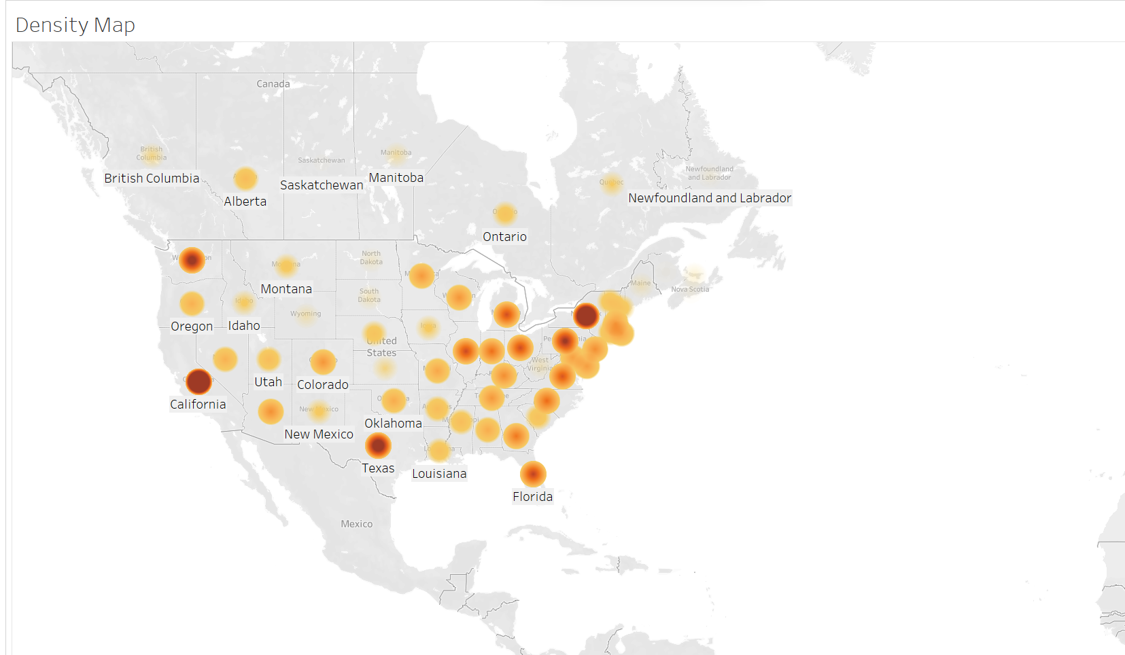 **4) Density Map**

**1)Hotspot Identification:-** Density maps are particularly useful for identifying hotspots or clusters. These are regions where data concentrations are significantly higher than in surrounding areas. Such information can be crucial for targeting resources, marketing efforts, or making business decisions.

**2)Data Concentration Visualization:-** Density maps excel at showing where data is concentrated. They use colour gradients to represent data density, with darker areas indicating higher concentrations. By observing the map, you can quickly identify hotspots of data activity.

# 

# 5)Spider Chart

# 

# 1)Relative Strengths and Weaknesses:- By comparing the distance of data points from the center of the chart, you can assess the relative strengths and weaknesses of each category in terms of the represented variables. Longer lines indicate higher values for that variable, while shorter lines indicate lower values.

# 6)Flow Map:-

# 1)Source-Destination Relationships:- Flow charts are excellent for depicting source-to-destination relationships. In this context, you can observe the flow of flights from one airport (the source) to another airport (the destination). By examining the flow lines, you can quickly identify the most popular routes and connections.

# 2)Flow Management:- For airlines or airports, flow charts can be used for managing and optimizing flight schedules, as well as for identifying potential bottlenecks in the network.

# Conclusion:-

# Data Quality: Ensure the quality and accuracy of your geospatial data. Inaccurate or incomplete data can lead to incorrect conclusions and decisions. Data cleaning and validation are essential steps.

# Visualization: Effective visualization of geospatial data through maps, charts, and graphs helps communicate patterns and insights. Choose appropriate tools and techniques to create clear and informative visuals.

# Spatial Analysis: Employ spatial analysis techniques to uncover spatial relationships, patterns, and dependencies within your data. These methods can provide valuable insights into geographic phenomena.

# Data Sources: Understand the sources of your geospatial data and their reliability. Data may come from government agencies, commercial providers, or crowdsourced platforms. Choose sources that best suit your analysis needs.

# Interdisciplinary Applications: Recognize the wide range of applications for geospatial data in fields like urban planning, environmental science, public health, logistics, marketing, and disaster management. Tailor your analysis to the specific domain.

# Ethical Considerations: Address privacy and ethical concerns, especially when dealing with sensitive or location-specific data. Ensure compliance with data protection regulations and ethical standards throughout your geospatial analysis.

**Date:-08/11/2023. Signature of faculty in-charge**

# Post Lab Question:

# Explain the Choropleth maps. A choropleth map in Tableau is a type of data visualization that is used to represent data on a geographic map, where different geographic regions are shaded or colored based on the values of a particular variable. This type of map is particularly useful when you want to visualize and analyze data that is related to specific geographic locations, such as countries, states, cities, or any other geographic boundaries.